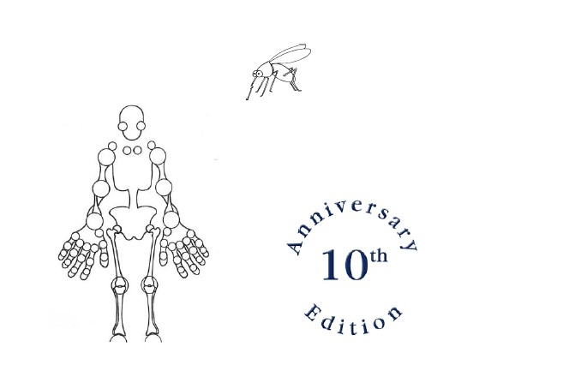
12

Programme
12th Dutch-Antillean-South American (DAS) Clinic of Rheumatology and Internal Medicine November 2021
Location: Aruba
Language: English

Accreditation for this continuing medical education (CME) activity is applied for at NIV (11 points) and subsequently for family practitioners and hospital specialists via their respective associations (NIV/NHG/NVR etc.).

DAS organizing team:
Sandro Waterloo MD, internist-elderly medicine, HOH, Aruba
Richard van Vugt MD PhD, rheumatologist, Amsterdam UMC, Amsterdam
Bert Rodenburg MD, internist-ID specialist, HOH, Aruba Ken Berend, MD PhD, internist, Curacao

Frida November 12

8.00 registration
8.30-9.00 Opening, J. Vroegop, medical director, HOH
9.00-9.30 Biologicals in primary care, S. van der Wal (HOH)
9.30-10.00 Costs and cost control in medical treatment on Aruba, M. Ongering (HOH)

Break

10.30-11.00 Best Practices in hypertension management, K. Kelly (HOH)
11.00-11.30 Management of diabetes mellitus: New drugs and current guidelines, J. Schakel (CMC)
11.30-12.00 Immunotherapy in oncology: what to expect, M. Ladenius (HOH)

Lunchbreak

13.30-14.00 Covid on Aruba, G. Tromp, (Public health department, Aruba) and B. Rodenburg (HOH)
14.00-14.30 Covid on ICU: prolonged proning of patients, R. Ramos (HOH)
14.30-15.00 After the Storm: Severe COVID survivorship, C. Becker (HOH)

Break

15.30-16.00 AntiVAX movement, K. Berend (CMC)
16.00-16.30 Covid vaccines and scientific breakthroughs, prof. dr. Duits (Curacao)

Saturday November 13

8.00 registration
8.30-9.00 Hyperprolactinemia, what about it? S. Rahamat (HOH)
9.00-9.30 Update in IBD, C. Franca (HOH)
9.30-10.00 The Latest in CKD, R. Kock (HOH)

Break

10.30-11.00 Update in rheumatoid arthritis, R.van Vugt (Amsterdam UMC)
11.00-11.30 Rheumatology in Aruba: paving the way for better care, (HOH), R. Rellum (HOH)
11.30-12.00 Therapeutic possibilities in patients with arthritis/arthrosis, B. Poelman (HOH)

Lunchbreak

13.30-14.00 Impaired kidney function, help! N. Ajubi (CMC)
14.00-14.30 The most common STDs, B. Rodenburg (HOH)
14.30-15.00 Barriers to HIV care among undocumented HIV patients, J. de Kort (HOH)

Break

15.30.16.00 Prevention in the elderly, S. Waterloo (HOH)
16.00-16.30 Dizzyness matters!, M. Smid (HOH)

Speakers and chairs:
Sandro Waterloo MD, internist-elderly medicine, HOH, Aruba
Jaclyn de Kort MD, internist-ID specialist, HOH, Aruba
Max Ongering MD, clinical pharmacologist, HOH, Aruba
Sabine van der Wal, clinical pharmacologist, HOH, Aruba
Ashley Duits MD PhD, medical immunologist, Head of Blood Transfusion Centre, Curacao
Richard van Vugt MD PhD, rheumatologist, Amsterdam UMC, Amsterdam
Rashidi Rellum MD, rheumatologist, HOH, Aruba
Bert Rodenburg MD, internist-ID specialist, HOH, Aruba
Ken Berend MD PhD, internist-nephrologist, CMC, Curacao
Nouaf Ajubi MD, internist-nephrologist, CMC, Curacao.
Barbara Poelman, ergotherapeut, HOH, Aruba
Romeo Kock MD, internist-nephrologist, HOH, Aruba
Karina Kelly MD, Internist, HOH, Aruba
Machiel Smid MD, Internist-elderly medicine, HOH, Aruba
Chris Franca MD, gastroenterologist, HOH, Aruba
Shabiet Rahamat MD, internist-endrocrinologist, HOH, Aruba
Ruben Ramos MD, intensivist, HOH, Aruba
Marianne Ladenius MD, internist-oncolgist, HOH, Aruba
Caroline Becker MD, pulmonologist, HOH, Aruba
Joris Schakel MD, internist-elderly medicine, CMC, Curacao
Garreth Tromp, epidemiologist, Department of public health, Aruba

